Database Design and Implementation Report

SID: 2203834

MOD002589

Date: 30.11.2023

1. **Introduction**

The purpose of the following report is to demonstrate the knowledge and understanding of the concepts introduced within the Database Design and Implementation module. The report documents the research of selected e-commerce websites, extraction, and analysis of attributes stored by those websites, before moving on to the design of the proposed Database. The initial design has been thoroughly analysed and validated using normalization techniques and that process has been documented in the relevant sections. The Database has been created according to the design and filled in with test data. Finally, sample SQL queries have been produced to test the Database.

Resources used:

The following resources were required to successfully complete this task:

• Google Chrome web browser – to gather information

• draw.io – to create a basic design for the database

• XAMPP control panel and MySQL to develop the database and create queries

• phpMyAdmin database administration tool, version 4.5.1

**2. Requirement Analysis**

2.1 Description of the Three Websites Chosen

All three websites, amazon, eBay, and Argos, selected for this task are online shopping sites, from which customers can purchase a variety of products distributed by individuals and companies. To examine the websites' functions, I registered as a new customer, browsed the product categories, selected a product, looked at the review section, and added it to the basket.

2.1.1

Amazon is a multinational technology and e-commerce company. It started as an online bookstore and expanded into a diverse range of products and services, including retail, cloud computing, streaming, and artificial intelligence. Amazon is a major player in global online commerce and technology innovation.

2.1.2

eBay is a global online marketplace that facilitates consumer-to-consumer and business-to-consumer sales. It enables individuals and businesses to buy and sell a wide range of new or second-hand goods through auctions or fixed-price listings.

2.1.3

Argos is a British retailer known for its catalogue-based shopping and diverse product range, including electronics, furniture, and household items. Operating both online and through physical stores, Argos offers both a delivery and click-and-collect service, allowing customers to order online and pick up their purchases at a nearby store or receive them at home.

2.2 Table of Data Fields

Three lists of attributes have been presented in the subsections below. By analysing the steps required to successfully purchase a product on each of the three websites I have been able to gather the list of attributes. The attributes were obtained by looking into what details needed to be filled by the Customer, information displayed by the website's product search page, the customer basket, and the checkout pages.

The attributes in each of the three tables have been listed under relevant columns to improve readability. The attributes are grouped relating to the entities Customer, attributes related to the Product, attributes linked to Basket, and shows Order related data.

2.2.1

Table of data fields from www.amazon.co.uk website

Table 1, below, contains the data fields extracted during the analysis of www.amazon.co.uk website.

|  |  |  |  |
| --- | --- | --- | --- |
| Customer | Product | Basket | Order |
| First and last name | Product Title | Product | Delivery address |
| Mobile number | Product price | Product quantity | Delivery instructions |
| Email | Amount Product was discounted by | Product stock | Payment method |
| password | Product information | Order subtotal | Billing address |
|  | Products related to the item | Total-amount | Giftcard/vouture/promocode |
|  | Product reviews |  | Offers |
|  | Product rating |  | Items |
|  |  |  | Delivery date |
|  |  |  | Delivery type |

Table 1: table of data fields extracted from the Amazon website.

During the registration process the user is required to provide either an email address or phone number to identify the customer and ensure they are not a robot and have entered their own contact details, verified by a verification code the customer must enter to create their account.

It is important to note that since the website deals with a large catalogue of items the attributes for each are very different. Due to this, only general attributes have been presented in the above list.

Each Product is related to a large range of other products of the same brand, similar names, or similar uses in order of the average customer rating, price, or brand.

The Payment-related attribute list contains some fields that are pre-filled with data referenced from elsewhere, such as the subtotal and total amount taken from basket. It is worth mentioning that although the user is required to enter details like Card number or Verification code, the details are most likely not stored in the database and so these attributes have not been included in Table 1.

Figure 1 shows “your account” found in the “All” section of the amazon website.

Figure 1: Screenshot of Your Account section on Amazon website

Figure 2 shows the Basket section of the Amazon website.

Figure 2: screenshot of the Shopping Basket section on the Amazon website

Figure 3 shows the “Checkout” section of the Amazon website.

Figure 3: screenshot of Checkout section on Amazon website

2.2.2

Table of data fields from www.ebay.co.uk website

Table 2, below, contains the data fields extracted during the analysis of www. ebay.co.uk website.

|  |  |  |  |
| --- | --- | --- | --- |
| Customer | Product | Basket | Order |
| First name | Product Title | Product | Delivery address |
| Surname | Quantity | Quantity selected | Payment method |
| Business/personal | Stock | Number sold | Billing address |
| Email | Price | % of positive feedback | Voucher |
| Password | Postage date | Items price | Offers |
|  | Return policy | Postage price | Delivery date |
|  | Condition | Total price | Delivery type |
|  | About this item |  | Product |
|  | Business seller information |  | Quantity selected |
|  | Product ratings and reviews |  | Postage date |
|  |  |  | Postage price |
|  |  |  | Total price |

Table 2: table of data fields extracted from the Amazon website.

It is important to note that since the website deals with a large variety of products ranging from technology to toys, the attributes of each item are very different. Due to this, only general attributes have been presented in the above list.

As the website deals in the sale of items of varying conditions, the condition of the items is displayed to the viewer on the item page.

Figure 4: Screenshot of Create an account section on eBay website

Figure 5 shows the section where the product is displayed website.

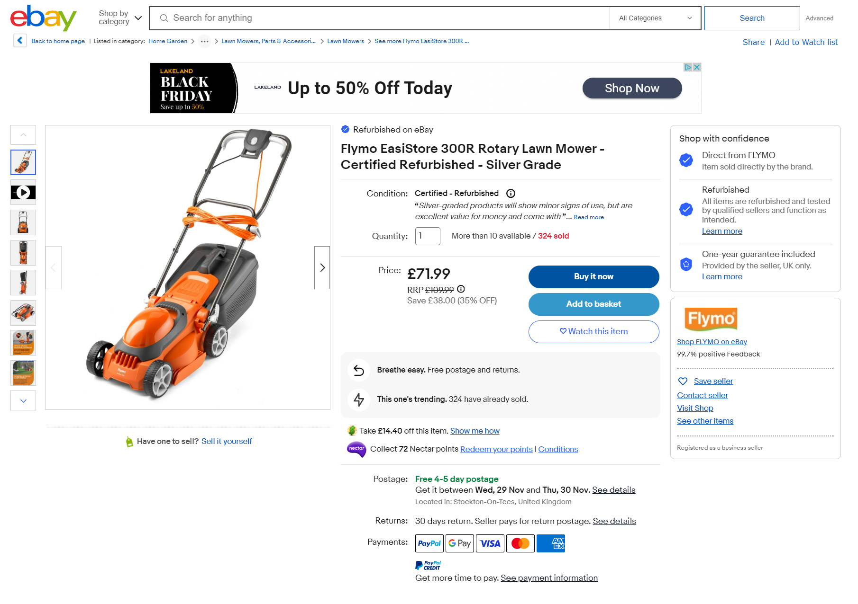Figure 5: screenshot of the item page on ebay website

Figure 6 shows the “Checkout” section of the eBay website.

Figure 6: screenshot of Checkout section on eBay website

2.2.3

Table of data fields from www. argos.co.uk website

Table 3, below, contains the data fields extracted during the analysis of www.ebay.co.uk website.

|  |  |  |  |
| --- | --- | --- | --- |
| Customer | Product | Basket | Order |
| Email | Product Title | Product | Delivery address |
| Title | Product price | Product quantity | Store location |
| First name | Stock near postcode | Delivery address/Collection address | Delivery instructions |
| Second name | Product information | Order subtotal | Delivery date |
| Postcode | Products related items | Total-amount | Payment method |
| Phone number | Product reviews |  | Gift card |
| Password | Product rating |  | Items |
| Receive marketing info | Customer Questions |  |  |
|  | Special offers |  |  |

Table 3: table of data fields extracted from the Amazon website.

The Argos store differs from the previous two stores as it provides a “click and collect” service that works in a similar way to how deliveries work though the customer will enter their post code and have the product(s) delivered to a physical store.

Figure 7 & 8 show the registration section for the Argos website.

Figure 7: Screenshot of registration page on Amazon website

Figure 8: Screenshot of registration page on Amazon website

Figure 9 shows a product page on the Argos website.

Figure 9: screenshot of product section on Argos website

Figure 10: screenshot of the trolly section of the Argos website

2.3 Finalised List

2.3.1. The Generic List

Table 4 shows a table of all the relative attributes obtained from all three websites. Several other attributes have also been rejected and justification is presented in Section 2.3.2. Similarly, some attributes have been added to the list, with the details and justification shown in Section 2.3.3.

|  |  |  |  |
| --- | --- | --- | --- |
| Customer | Product | Basket | Order |
| Customer ID | Product ID | Basket_ID | Order_ID |
| Title | Product name | Products | Delivery address |
| First name | Quantity in stock | Quantity selected | Payment method |
| Surname | Price | Items price | Billing address |
| Email | Return policy | Total price | gift cards/promo code |
| Phone number | Condition |  | Delivery date |
|  | Product info |  | Product |
|  | Business seller information |  | Quantity selected |
|  | Product review |  | Postage price |
|  | Customer Questions |  | Total price |
|  | Sale details |  |  |
|  | Item ID |  |  |

Table 4: table of data fields obtained by merging relevant data from Tables 1,2 and 3

2.3.2 Justification for the Attributes Rejected

I have removed attributes related to “click and collect” options and left in attributes regarding delivery, as my proposed system is an online-only store where the customer will only be receiving products to their desired address.

The attribute relating to the account type in Table 2 has been removed as the proposed system will offer only one type of account for customers.

2.3.3 Justification for the Attributes Added

I have added “item ID”, this would be a hidden entity as it would not be viewable to the customer. The purpose of this is to allow the seller to keep track of stock as each individual item of the same type or product will be accounted for and removed from stock once that item has been sold

**3. Database design**

3.1 Entity Relationship Modelling

During the database design, several models have been created for each step; the first being an entity-relationship diagram presented in section 3.1.1. From this, I developed a more complex Extended Entity Relationship diagram(EERD) model presented in section 3.1.2 below.

3.1.1 Initial Entity Relationship Model

Figure 19: Entity Relationship Diagram

3.1.2 Extended Entity Relationship Model

From the ERD in Section 3.1.1 I developed a more detailed Extended Entity Relationship Diagram (EERD) that includes attributes, primary keys and foreign keys.

Figure 20: Extended Entity Relationship Diagram

3.2 Normalised Model

Through the use of normalization, I developed and validated my final EER model to ensure the relationship between entities would support the data requirements. This was an important step to helping me discover semantic errors allowing me to improve the model.

3.2.1 Normalization (1NF-3NF)

The initial model shown in Figure 20, Section 3.1.2 did not contain some repeating groups of attributes, however, each entity had an identifying key, this meant it needed some improving to pass the First Normal Form (1NF). I improved this by removing repeating attributes and removing the basket table as it contained only repeating attributes.

The final model did not contain any composite primary keys, and so passed the Second Normal Form (2NF) test.

The final model contained no non-key attribute, therefore passing the Third Normal Form (3NF) test.

The initial model did not comply with the three Normal Forms, and so the in-depth analysis uncovered errors I was able to improve on and showed me new features I could implement such as the item, and seller.

3.2.2 Extended Entity Relationship Model Derived from the 3NF Entities

Figure 21 shows the EER model of the proposed database and has been normalized by performing a series of normalization tests to ensure that the grouping of the attributes, and relationships between the entities support the data requirements. A screenshot of a computer

Figure 21: EER Diagram used to implement the proposed Database

3.3 Database Schema

The proposed database consists of 5 tables:

* Customer
* Order
* Product
* Item
* Seller

|  |  |  |
| --- | --- | --- |
| Customer | | |
| Attribute name | Type | Description |
| Customer_ID | Int(25) | Primary key, indexed |
| Title | Varchar(15) | Stores customers honorific |
| First_name | Varchar(20) | Stores customers first name |
| Surname | Varchar(20) | Stores customers surname |
| Email | Varchar(50) | Stores customers email |
| Phone_no | Int(13) | Stores customers phone number |

Table 6: The description of attributes stored in Customers table

|  |  |  |
| --- | --- | --- |
| Order | | |
| Attribute name | Type | Description |
| Order_ID | Int(25) | Primary key, indexed |
| Customer_ID | Int(25) | Foreign key referenced from Customer table, indexed. |
| Product_ID | Int(25) | Foreign key referenced from Product table, indexed. |
| Delivery_address | Varchar(20) | Holds the delivery address |
| Payment_method | Enum(visa, mastercard, maestro) | Holds the payment method |
| Billing_address | Varchar(20) | Holds the billing address |
| Gift_card | Int(25) | Stores the gift card number |
| Promocode | Varchar(10) | Stores the promocode |
| Delivery_date | Datetime | Stores predicted delivery time |
| Quantity | Int(10), unsigned | Stores customers desired quantity of product, indexed |
| Postage_price | Decimal(8, 2), unsigned | Stores the postage price |
| Total_price | Decimal(8, 2), unsigned | Stores the total price |

Table 7: The description of attributes stored in Order table

|  |  |  |
| --- | --- | --- |
| Product | | |
| Attribute name | Type | Description |
| Product_ID | Int(25) | Primary key, indexed, |
| Item_ID | Int(25) | Foreign key referenced from Item table, indexed |
| Product_name | Varchar(10) | Holds product name |
| Product _info | Varchar(20) | Holds product info |
| Product _review | Varchar(25) | Holds product reviews |
| Stock | Int(20) | Stores total stock |
| Customer_questions | Varchar(20) | Holds customer questions |

Table 8: The description of attributes stored in Product table

|  |  |  |
| --- | --- | --- |
| Item | | |
| Attribute name | Type | Description |
| Item_ID | Int(25) | Primary key, indexed. |
| Seller_ID | Int(25) | Foreign key referenced from Seller table, indexed |
| Item_price | Decimal(8, 2) | Holds item price |
| Condition | Enum(second-hand, first-hand) | Holds the condition |

Table 9: The description of attributes stored in Item table

|  |  |  |
| --- | --- | --- |
| Seller | | |
| Attribute name | Type | Description |
| Seller_ID | Int(25) | Primary key, indexed. |
| Seller_name | Varchar(15) | Holds seller name |
| Seller_address | Varchar(20) | Holds seller address |
| Seller_contact_into | Varchar(20) | Holds seller’s contact into |

Table 10: The description of attributes stored in Seller table

**4. Database Implementation**

The Database for the proposed system has been build using phpMyAdmin. All of the test records have been inserted manually using insert SQLquerys.

Figure 22 the list of tables with their storage engine and number of rows.

Figure 22: Screenshot of the details of the database

Figure 23: Screenshot of customer table structure

Figure 24: Screenshot of customer table rows and columns

Figure 25: Screenshot of item table structure

Figure 26: Screenshot of item table rows and columns

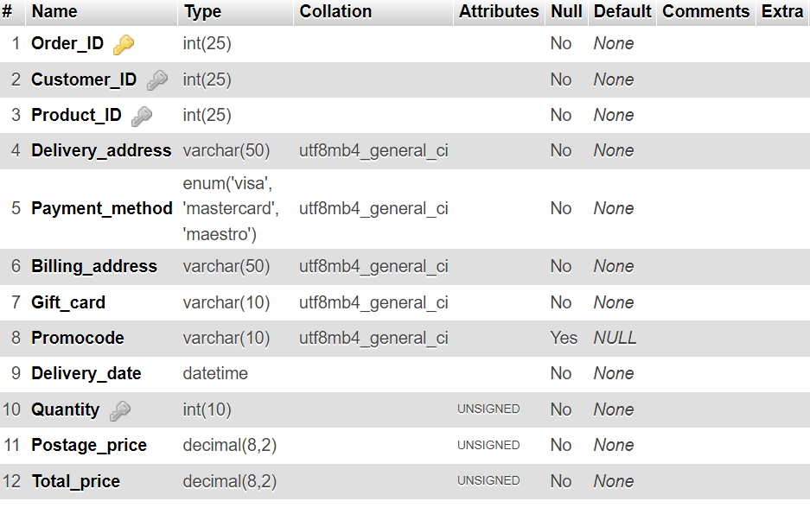

Figure 27: Screenshot of order table structure

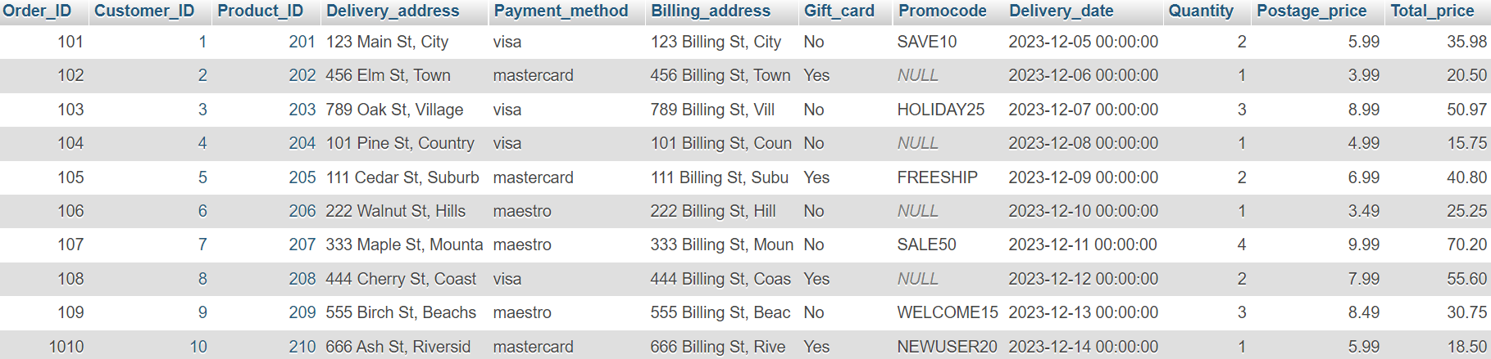

Figure 28: Screenshot of order table rows and columns

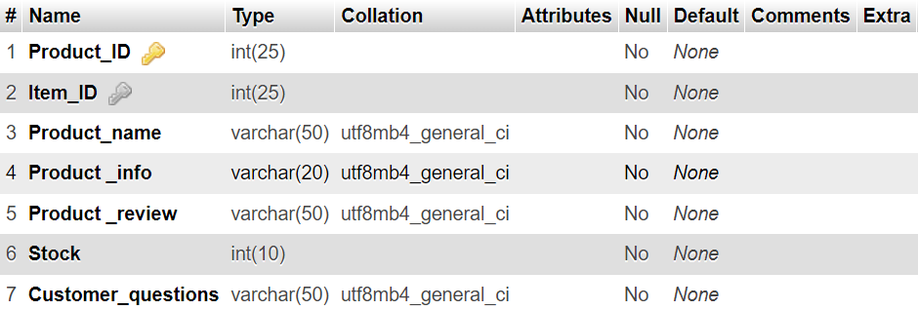

Figure 29: Screenshot of product table structure

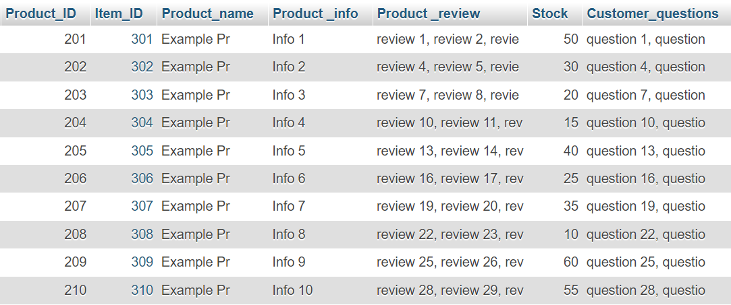

Figure 30: Screenshot of product table rows and columns

Figure 31: Screenshot of seller table structure

Figure 32: Screenshot of seller table rows and columns

**5. SQL Queries**

The select queries are designed to extract data customers and sellers would likely use from the proposed database. As such the queries imitate user stories from the perspective of the online store's customers and sellers.

5.1.1 User Story.

As a seller, I want to know the name and address of my customers.

5.1.2 SQL Code and Output

Figure 33: Screenshot showing SQL query.

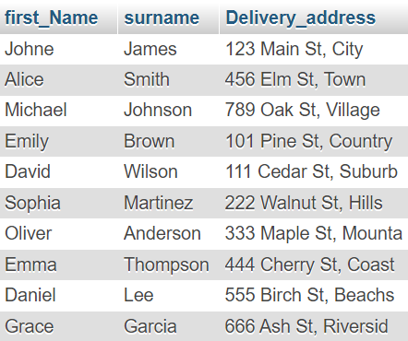

Figure 34: screenshot of output generated by query

5.1.3 Explanation of the Query's Output

The output of this query produces a list of customers full names and addresses, allowing the seller to ship items to the correct location.

5.2.1 User Story

As a customer, I want to read a product's information and see its price.

5.2.2 SQL Code and Output

Figure 33: Screenshot showing SQL query.

Figure 34: Screenshot of output generated by the query

5.2.3 Explanation of the Query's Output

The output of this query produces a list of a specified product’s name and info from the product table, and the item price from the item table.

5.3.1 User story

As a customer, I want to be able to update my email and phone number.

5.3.2 SQL Code and Output

Figure 33: Screenshot showing SQL query.

Figure 34: screenshot of output generated by query

5.3.3 Explanation of the Query's Output

The SQL query changes the contact details of the chosen customer by directly accessing their email and phone number in the customer table where the chosen customer’s id is equal to the customer id.

5.4.1 User Story

As a seller, I would like to see the reviews of my products from my customers.

5.4.2 SQL Code and Output

Figure 37: Screenshot showing SQL query.

Figure 38: screenshot of output generated by query

5.4.3 Explanation of the Query's Output

The output of this query produces a list of product reviews given by customers who bought the same product, it also gives the full name of the customer to show what different people thought about the product. The product name and reviews are taken from the product table and the first name and surname are taken from the customer table.

5.5.1 User Story

As a customer, I would like to find the contact details of the person who sold me my product.

5.5.2 SQL Code and Output

Figure 39: Screenshot showing SQL query.

Figure 40: screenshot of output generated by query

5.5.3 Explanation of the Query's Output

The output of this query produces a list of the sellers details for a customer who bought the seller's product to allow them to return a parcel or get in contact with the seller, it does this by presenting the seller's name, address, and email from the seller table.

**6. Conclusion**

From this module, I have learned how to identify and examine a website to outline the entities and attributes they may contain, these being both hidden and not hidden, and form them into a list. I have also learned how to model the list of entities and attributes I have gathered into an EERD using the three forms of normalisation, and schemas such as keys(primary and foreign), data types, and data ranges, and the importance of these schemas. I have also learned how to use software to build tables that represent the entities and populate these tables using SQL queries that insert data to the relevant columns. Finally, this module has taught me how to develop SQL queries to show specific data throughout the database I have designed and implemented.